
LAB TASK 04

My Assumptions:
- The h value are abstract time estimates in the edge cost unit not real distances
- The graph is directed & all costs are positive.
- Start is S & goal are G.
- A node is expanded only when its successors are checked. Popping the goal is logged, not counted
- Stale queue entries are ignored.
- Ties: lowest f then lowest g, then node name.
- Successors are added in graph order (A before B)
- UCS is the same code with every h at 0, which keeps the comparison fair.

Problem Description:
- The campus navigation system has to find the cheapest route from building S to building G.
- For every node n it knows two things. g(n) is the actual cost paid so far & h(n) is an estimate of the cost that is still left.
- A* chooses the next node to takes by using f(n) == g(n) + h(n).
- The graph gives these edge costs in time: S→A = 1, S-→B = 4, A--->C = 2, B→G = 5, C→G = 3
- The heuristic values are h(S) == 5, h(A) = 4, h(B) = 4, h(C) = 2, h(G) = 0
- Route 1 is S→A→C→G & its cost is 1 + 2 + 3 => 6
- Route 2 is S→B→G and its cost is 4 + 5 => 9
- So the best cost is 6 & it come from Route 1
- Aim 1 is to find the best path with A*
- Aim 2 is to compare A* with UCS by looking at the expanded nodes.
- Aim 3 is to check what happens when one h value is an overestimate.

Implementation Decisions:

- The language is Python and only the math module is used.
- The frontier is priority queue & the entry with the smallest f comes out first.
- A dictionary keeps the lowest g found for each node, and a cheaper path found later replaces the old one.
- An entry whose g is worse than the stored one is stale so it is skipped & count
- UCS uses the same function with h = 0 for every node soo only the heuristic changes
- The code records trace of expanded nodes and the stale count soo every claim comes from the measured output
- The code are split into three files: astar_ucs.py (A* and UCS), lab4_astar_audit.py (audit and Task 2) and lab4_task3_overestimate.py (Task 3)

Task 01:

Hand writen

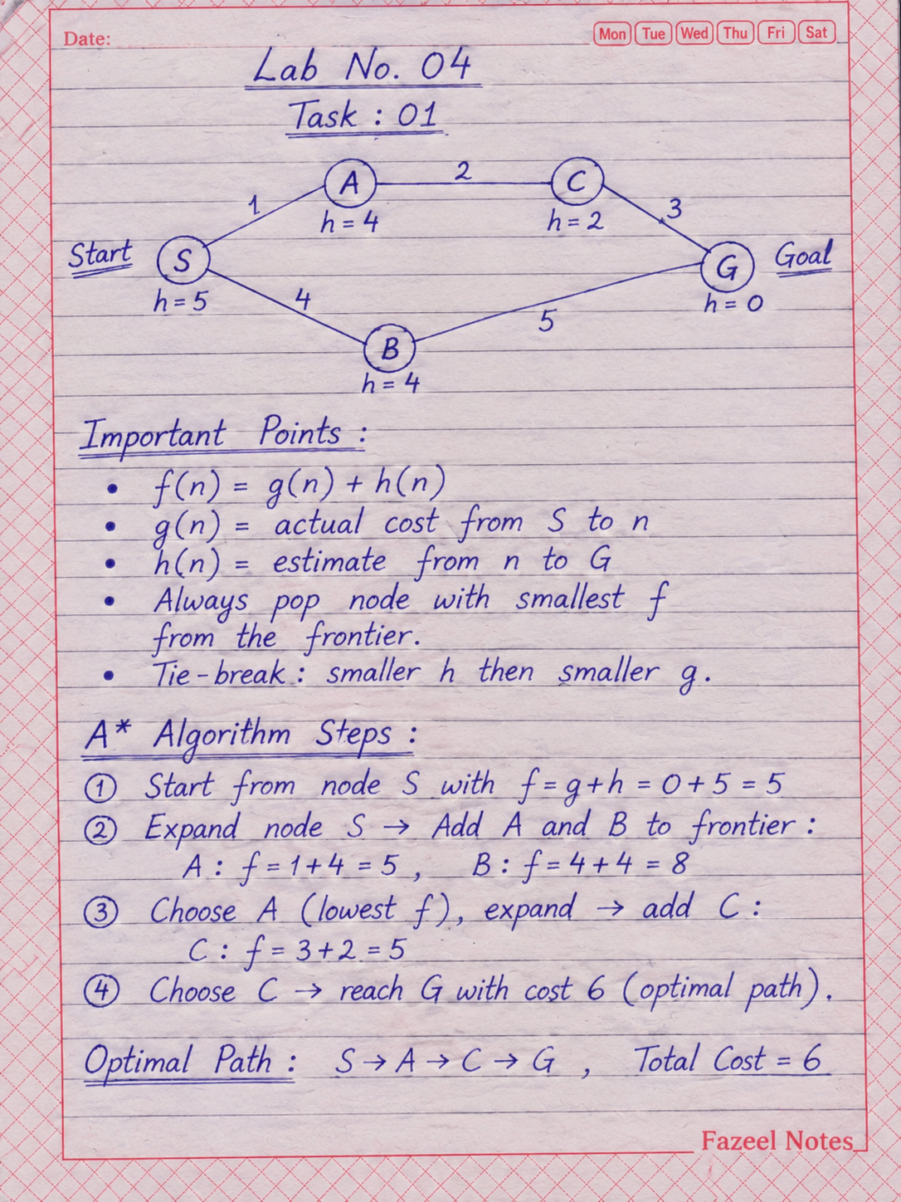
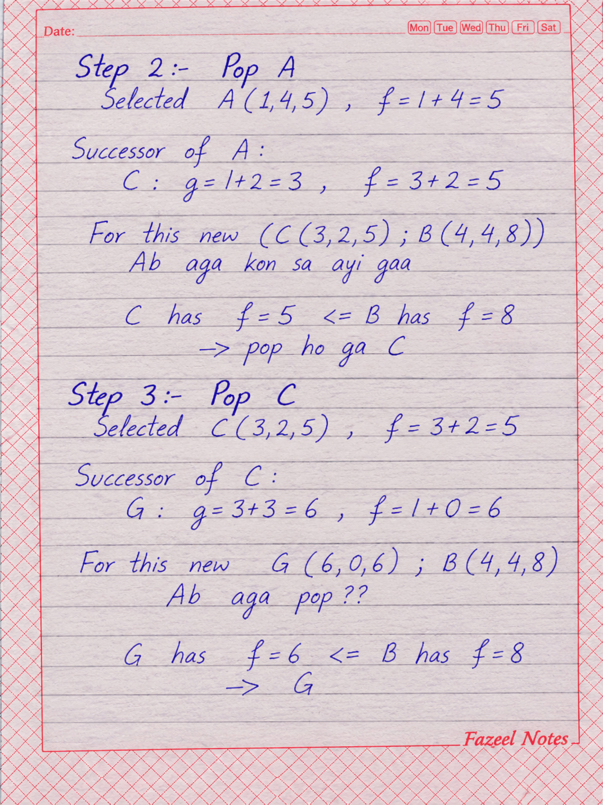
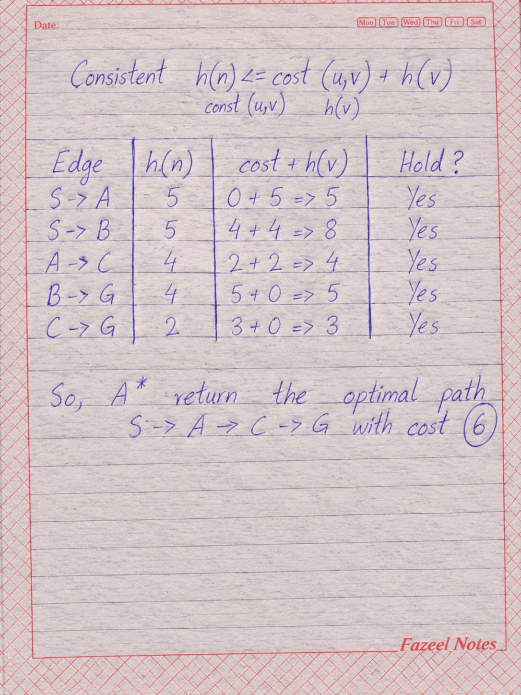
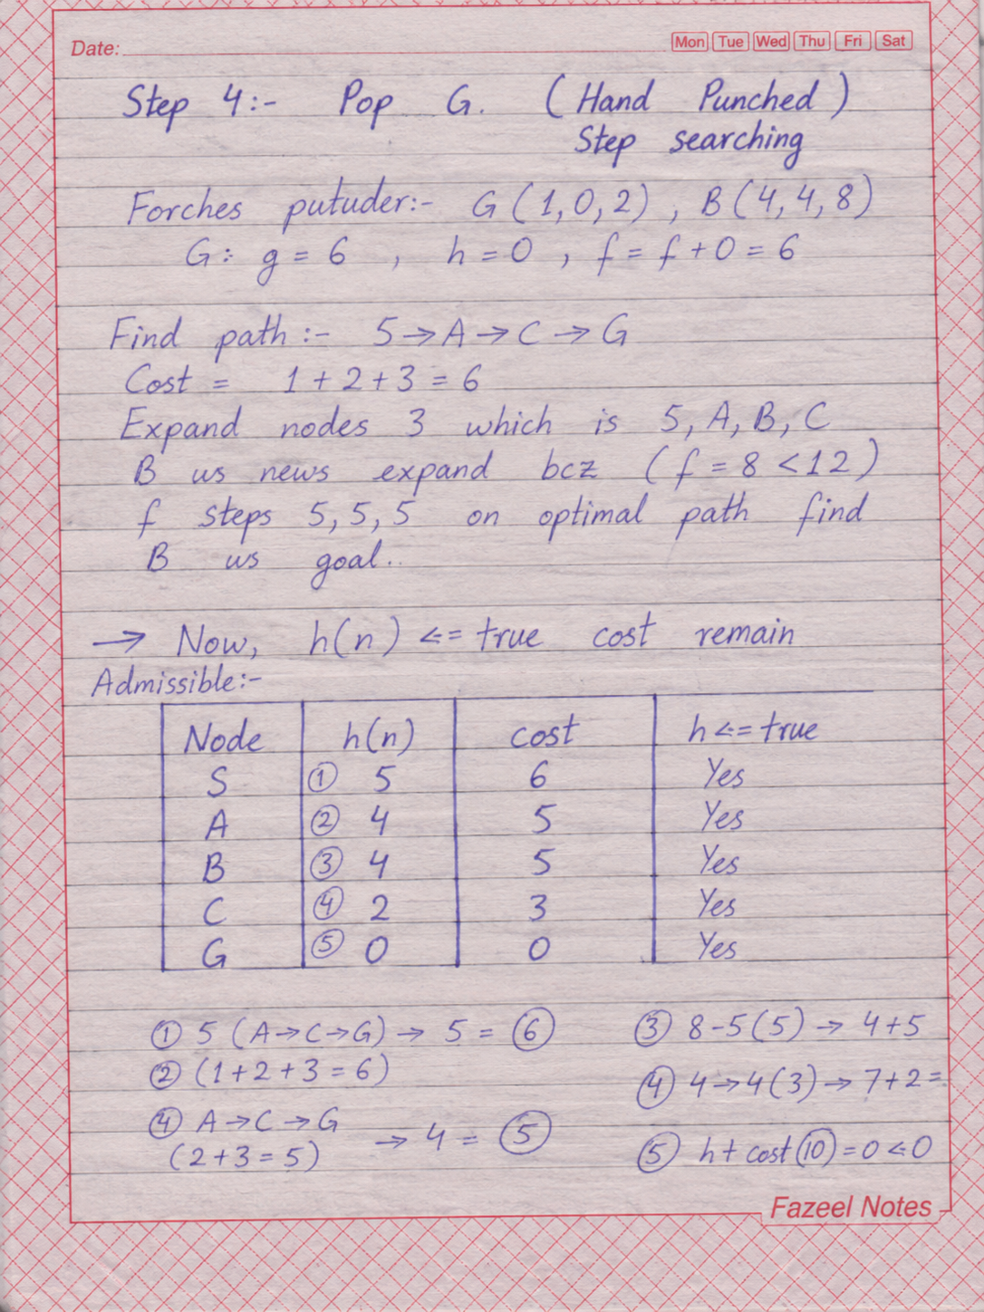
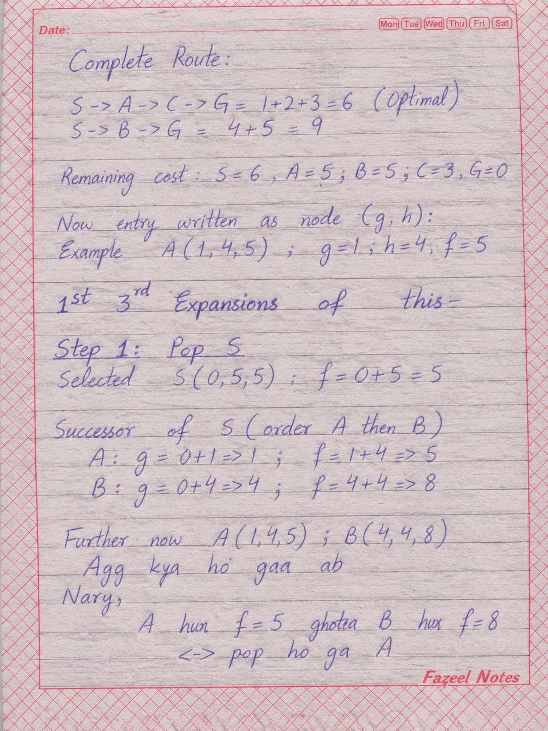
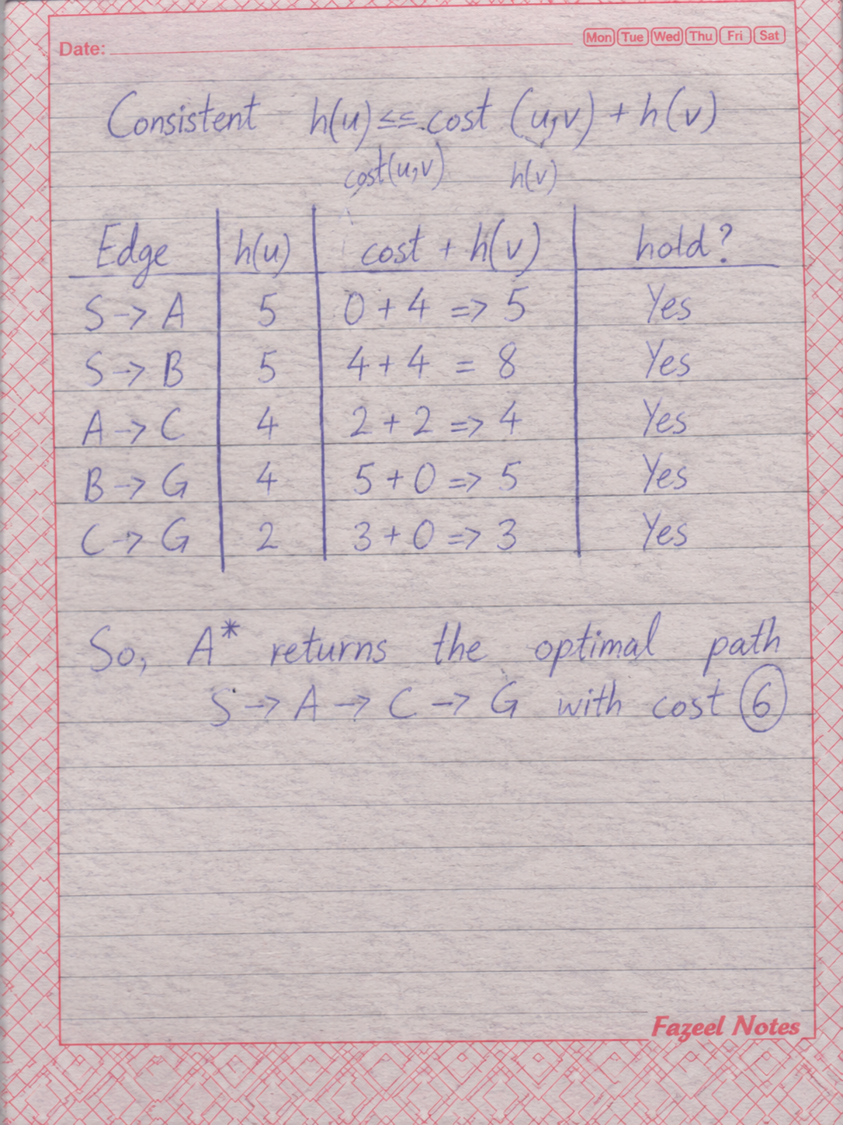

Task 02: A* vs UCS

Both runs use the same graph start S & goal G. A* uses the supplied h values while UCS uses h = 0.
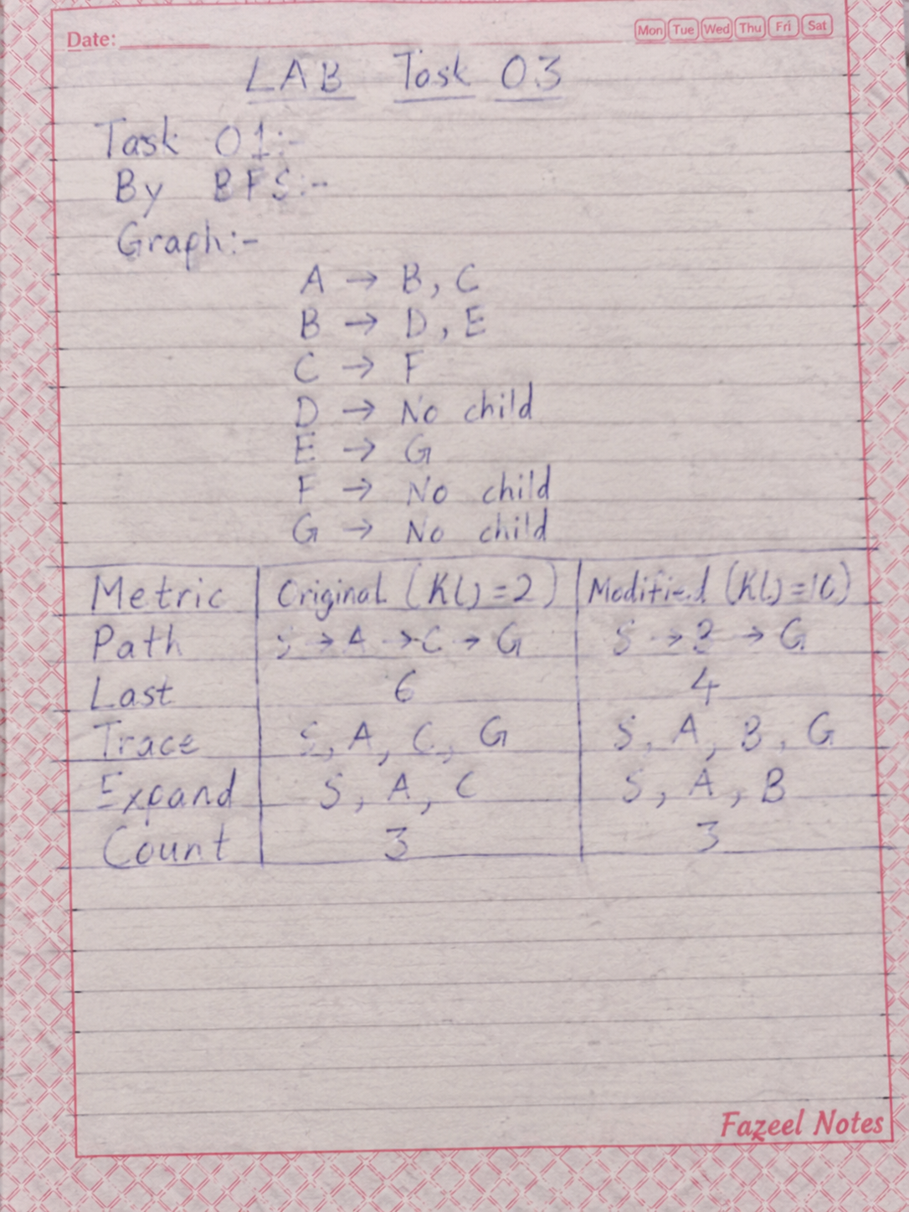

• How I count: A node are counted as expanded only when its outgoing edge are examined.
• About the goal: Popping G stops the search right away. G appears in the process trace but is left out of the expansion count.
• Stale entries in UCS: The edge B → G gives a candidate cost of (4+5=9). Since (9<6) is false the existing cost for G is not updat & no new entry is pushed.
• Reason for the different counts: A* does not expand B bcz (f(B)=g(B)+h(B)=4+4=8) is greater than goal cost of 6. UCS expands B bcz it orders node by (g(n)) & (4<6).
• Outcome: Both algorithms return the optimal path S → A → C → G with a total cost of 6. A* expand one fewer node than UCS.
TASK 03:

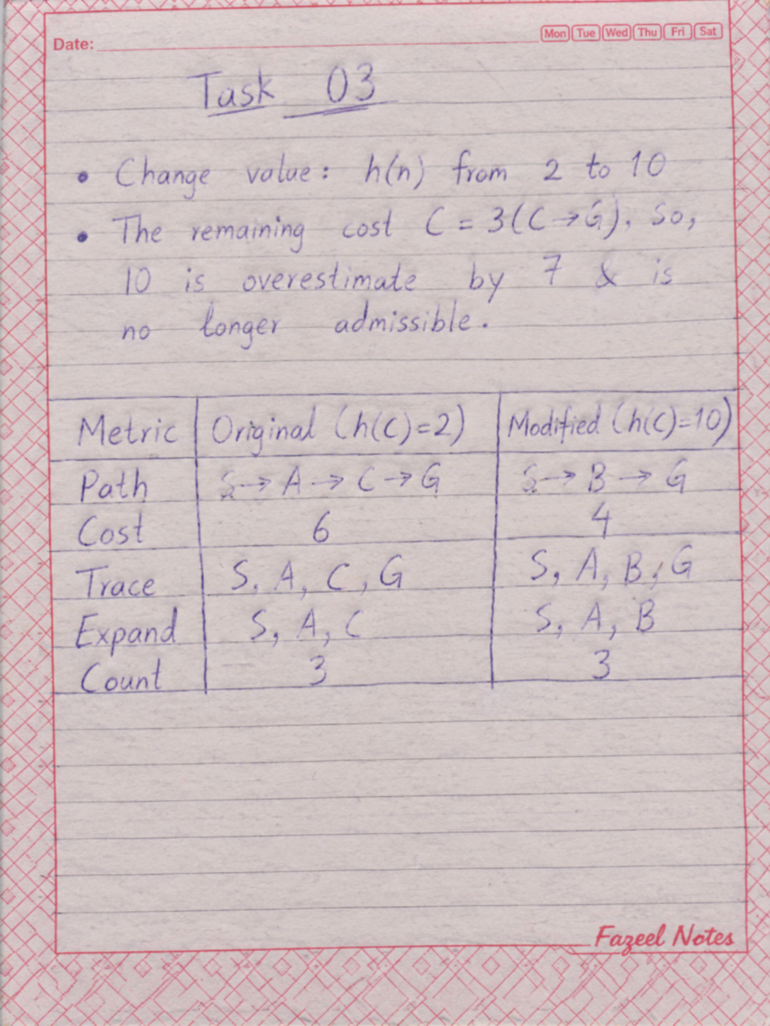

• Changed trace: A* expands S, A and B. Since (f(C)=3+10=13) & (f(B)=8), B is processed first. G is reached with cost 9 and popped before C
• What happened: The path changes from S → A → C → G (cost is 6) to S → B → G (cost is 9). The expansion count stays 3 but B replaces C.
• Why: The overestimated heuristic makes the optimal route through C look less promising.
• Optimal or not: (h(C)=10) is more than the actual cost of 3, so the heuristic is not admissible and A* loses its optimality.
• Remember: Even a smaller overestimate such as (h(C)=4) may still produce the optimal path. One successful run does not guarantee that heuristic is admissible.

Failure / Edge Case Study:
Point | What it says
What I tested | On the same graph h(C) is changed from 2 to 10 the remain cost of C is 3
What I saw | A star ended with the path S to B to G and its cost was 9 this was not the best path. The best path was S to A to C to G with cost 6. Node C stay in the list of node to check with value 13 & it was never expanded.
Probable reason | h(C) is 10 which are higher than the real cost of 3, soo h(C) is not admissible. Because of this f(C) becomes too large.
Suggested fix | Check the heuristic before running the A star algorithm. For example build it from relaxed version of the problem that uses the lowest possible cost of an edge. Then test it against uniform cost search on example problem.

Responsible Practice Points:

- All efficiency claims come from measurements on the graph with the same code not from guessing.

- A wrong heuristic can quietly return a route that still looks fine. In navigation it can mean a longer or less safe route, soo a heuristic must be tested and not just assumed.

- The A* starter code & the graph come from course lab manual

- The code, data & report contain no passwords or priavte information

- I did not upload any environment to GitHub

Limitations of the Work:

- The graph has only five nodes, so the expansion gap is small (A*: 3 UCS: 4).
- The h value are guesses & not real campus distances
- Different tie-break rules could change the results
- Only one pair of start and goal (S, to G) was tested.

My Reflection:
1. What did I learn in this lab?
A* uses f = g + h soo it combine the cost spent with a guess of the cost left. With an admissible heuristic it finds the best path and expands fewer nodes than UCS.

2. How can I use this in an AI system?
In route planning, maps or game AI I would build h from a simpler version of problem and test it before using it.

3. What surprised me the most?
Changing just one value h(C) = 10, made A* return a worse path (cost 9 instead of 6) the expansion count stayed 3.

4. What would I change next time?
I would test on larger graph, add program that check admissibility and try many start & goal pairs instead of only one pair

